Lab no 3
Topic : to familiar with OLTP system query execution
Objectives: To learn query execution in OLTP databases

An organization has a main data table that lists events. Each event has a series of fields including duration, reason code and status.
The OLTP system has a table of statuses with attributes status code and Name and there is a common field between the main table (status code), which allows the organization to print the status name rather than the code.
There are four statuses (ready, delay, spare and down) and there are a range of reasons associated with each status with reason codes. It is possible for the same reason code to exist in two statuses (e.g. delay maintenance and down maintenance).
For some reason, the source database has four tables of reasons (one for each status). Each of these has a field which links to the main reason code.
The organization wishes to do the following:
When the main table record status is ‘delay’, then retrieve the name in the ‘delay’ table which corresponds to the main table delay code. When the status is ‘down’, do the same thing but look up the name in the ‘down’ table.
Create Tables:
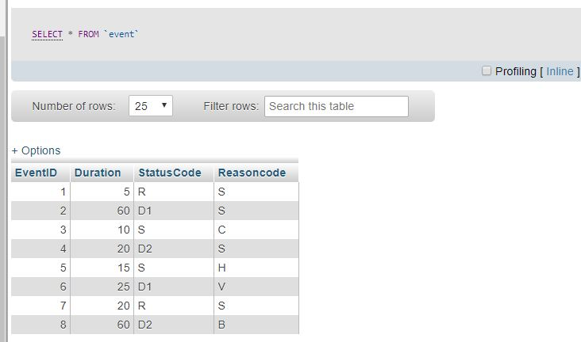
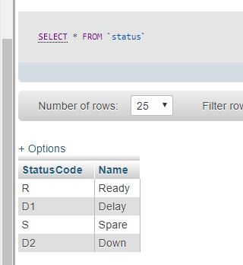
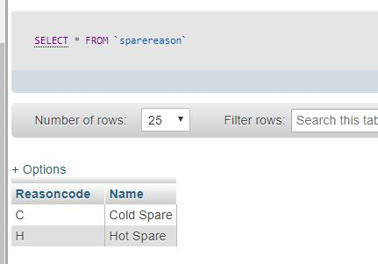
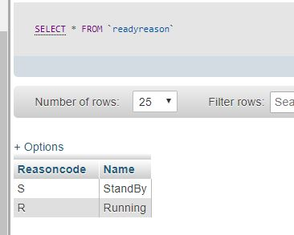
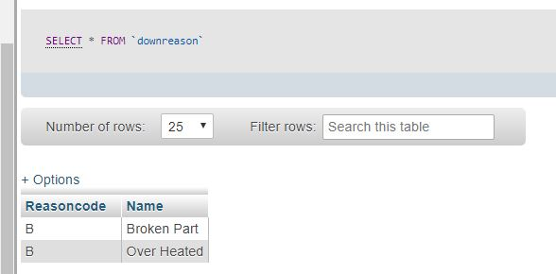
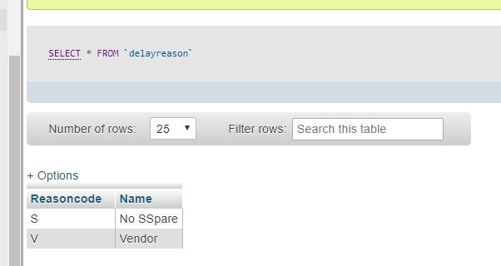
InnerJoin:
Inner join to return status name.
Query: SELECT EventID, Duration, S.Name FROM Event E INNER JOIN Status S ON E.StatusCode = S.StatusCode
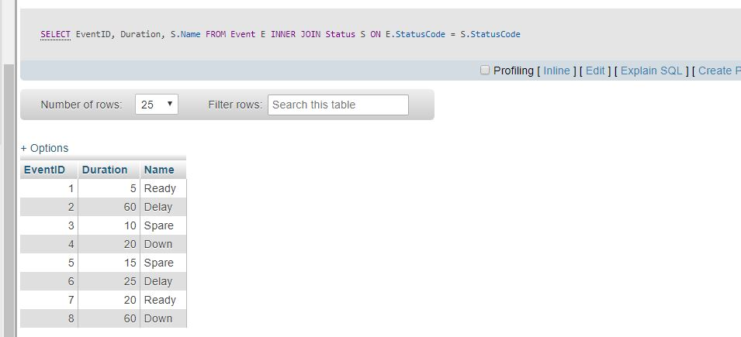

Union:
SELECT 'R', ReasonCode, Name FROM ReadyReason UNION SELECT 'D1', ReasonCode, Name FROM DelayReason UNION SELECT 'S', ReasonCode, Name FROM SpareReason UNIONSELECT 'D2', ReasonCode, Name FROM DownReason

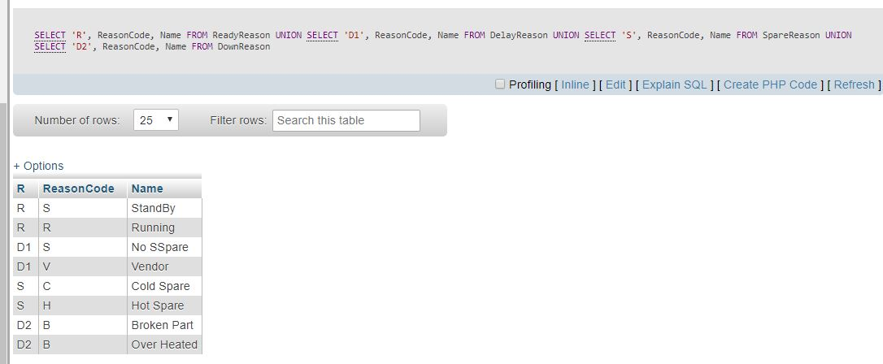

Query:
SELECT EventID, Duration,S.Name as [Status Name],
SR.ReasonName as [Rason Name]
FROM Event E
INNER JOIN Status S
ON E.StatusCode = S.StatusCode
INNER JOIN
(
SELECT 'R', ReasonCode, Name
FROM ReadyReason
UNION
SELECT 'D1', ReasonCode, Name
FROM DelayReason
UNION
SELECT 'S', ReasonCode, Name
FROM SpareReason
UNION
SELECT 'D2', ReasonCode, Name
FROM DownReason
) SR
ON E.StatusCode = SR.StatusCode AND
E.ReasonCode = SR.ReasonCode

